Thesis title
Subheading, if any

LAB University of Applied Sciences
Bachelor of … – type your degree here, for example Bachelor of Engineering
202X
Firstname (= given name) Lastname (= family name/surname)
 |  | Abstract
Author(s)  Lastname, Firstname | Publication type  Thesis, UAS | Published  20xx
Number of pages
xx
Title of Publication
Title of the thesis
Subheading, if any
Degree and field of study
e.g. Bachelor of Engineering, Mechanical Engineering
e.g.
Name, title and organisation of the client (if the thesis work is commissioned by another party)
e.g. Clint Client, Design Engineer M.Sc. (Tech.), Design Agency Ltd.
Abstract
Type the abstract text here …
Keywords
keyword, keyword, keyword

Contents
1 Introduction 1
2 Second main section 2
2.1 First subsection 2
2.1.1 Subsection of first subsection 2
2.1.2 Second subsection of subsection 2
2.2 Second subsection 2
3 Third main section 3
3.1 First subsection 3
3.1.1 Subsection of first subsection 3
3.1.2 Second subsection of subsection 3
3.2 Second subsection 3
4 Summary 4
References 5

Appendices
Appendix 1. Appendix title
Appendix 2. Appendix title

- Introduction
Read the thesis guidelines used at LAB University of Applied Sciences. Regarding writing the thesis report, read especially chapter 6, Thesis report’s language, style, illustrations, structure and layout, and chapter 7, Data collection and referencing mechanics. Follow the guidelines carefully.
This is the template used for writing thesis reports at LAB. Good skills in using a word processor help in writing a thesis report and using the thesis template. Therefore, before you start the writing process, it is advisable to ensure that you have sufficient basic skills in editing long documents with a word processor. These skills include the use of the Styles tool and an understanding of document sections and automatic references. Using these tools when writing a thesis report will probably save more hours than studying them takes.
To understand how to use this thesis template, you need to have internalised the following basics regarding MS Word:
- No text is positioned, nor any layout done, by adding multiple consecutive spaces or line or paragraph breaks. If you need to press Enter or Space bar more than once in succession, you are probably doing something wrong. When starting a new paragraph, press Enter once at the end of the line, and the space between the paragraphs is added using styles.
- It not advisable to produce any numbered data (paragraph numbers, page numbering, numbering of images/tables/figures/appendices) by manually entering the numbers. For all of these, Word provides powerful automated tools that keep numbering organised, even if you edit, add or delete data.
- Never add hyphens to words at the end of a line by manually typing them. In the thesis template, Word’s automatic hyphenation is enabled. If you need to add hyphens yourself, you can use the optional hyphen tool in Word.

- Second main section
  - First subsection
The first subsection heading (e.g. here 2.1) must always be followed by text, i.e., there cannot be three consecutive headings. This is sample text for the first subsection. This is sample text for the first subsection. This is sample text for the first subsection. This is sample text for the first subsection. This is sample text for the first subsection. This is sample text for the first subsection.
This is an example of a direct quote. This is an example of a direct quote. This is an example of a direct quote. This is an example of a direct quote. This is an example of a direct quote. This is an example of a direct quote. (Source 2020, 45.)
This is sample text for the first subsection. This is sample text for the first subsection. This is sample text for the first subsection. This is sample text for the first subsection. This is sample text for the first subsection.
    - Subsection of first subsection
This is sample text for the subsection of a subsection. This is sample text for the subsection of a subsection. This is sample text for the subsection of a subsection. This is sample text for the subsection of a subsection.
    - Second subsection of subsection
  - Second subsection
- Third main section
  - First subsection
    - Subsection of first subsection
    - Second subsection of subsection
  - Second subsection

- Summary and discussion

References
Tyler, B. 2010. Example source name. Diamond Education e-books. Dublin: InfoPoint Publishing
Virtanen, V. 2011. Example source title. LAB University of Applied Sciences. Retrieved on 1 January 2020. Available at http://example.fi
.
Appendix 1. Title
If the appendix consists of a single page, a page number is not added.
The next page starts an appendix that consists of several pages. This page must contain a section break: Layout/Breaks/Next Page.
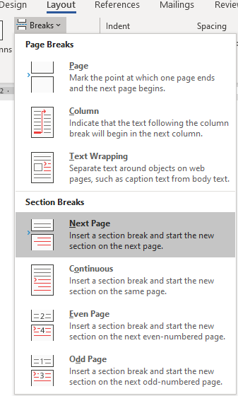

With non-printing characters visible, the document will show the page break as follows:

Appendix 2. Appendix title
If the appendix consists of more than one page, page numbering must be displayed. Note: Link to Previous must be disabled in the header. (Note that a section break was added on the previous page.)
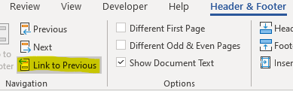

The story of appendix 2 continues...

Appendix 2, third page
If a third appendix comes after this, you must add a section break: Layout/Breaks/Next Page.

Appendix 3. Title
The story of appendix 3 starts here. If the appendix consists of one page only, no page number is added.
This means that you need to disable Link to Previous in the header,
and only then delete the page number.

